DFCS Forms Online Access Instructions

Introduction

The following instructions will assist you in gaining initial access to the DFCS Online and in navigating the use of the DFCS Forms Online.

Forms Access

The forms are now available on the World Wide Web within the Division of Family & Children Services web site.

To access DFCS Forms Online:

- Open the Internet Explorer web browser.
- In the Address Bar, type the http://dfcs.dhr.georgia.gov/formsonline as shown below and press ENTER on the keyboard.
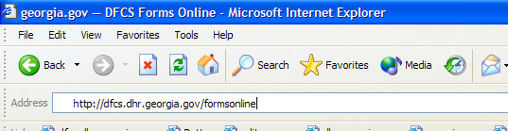

- Next, the DFCS Forms Online web page should appear as shown below.
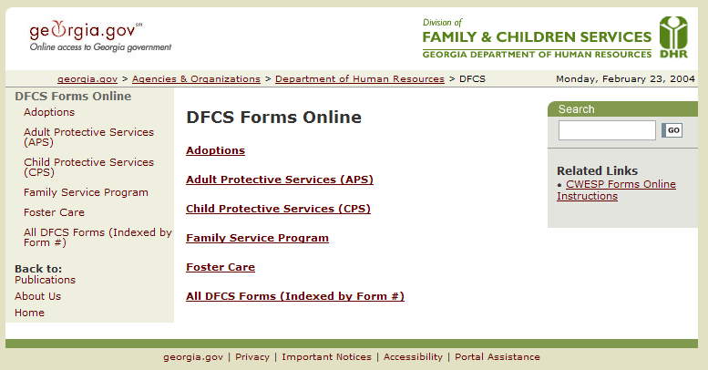

Forms Categorization

DFCS Forms Online categorization has been structured according to program areas within DFCS. Additionally, some categories have been broken down to include subcategories. As such, the category/sub-category breakdown is as follows:

- Adoptions
- Adult Protective Services (APS)
  - Intake
  - Investigations
  - On-going
- Child Protective Services (CPS)
  - Intake
  - Investigations
  - On-going
  - Special Investigations
- Family Service Program
- Foster Care
  - First Placement Best Placement (FPBP)
  - Residential Treatment Services
  - Resource Development
An additional category labeled All DFCS Forms (Indexed by Form #) was added for a quick reference to all the CWESP Forms by Form Number.
The diagram below indicates the categorization as displayed on the DFCS Forms Online web page.

Opening a Form

To Open a Form:

- Select a category from the list shown above. In this example, the Adult Protective Services (APS) category is chosen.
- Next, choose a subcategory, when applicable. In this example, the Investigations subcategory is chosen.

- Select the desired form by left-clicking the mouse while the cursor is over the appropriate link. In this example, the APS 182 form is chosen.
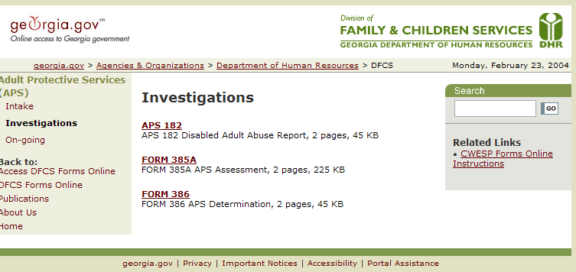

- After clicking APS 182 the Microsoft Word version of the form will load within your Internet Browser (i.e., Internet Explorer).
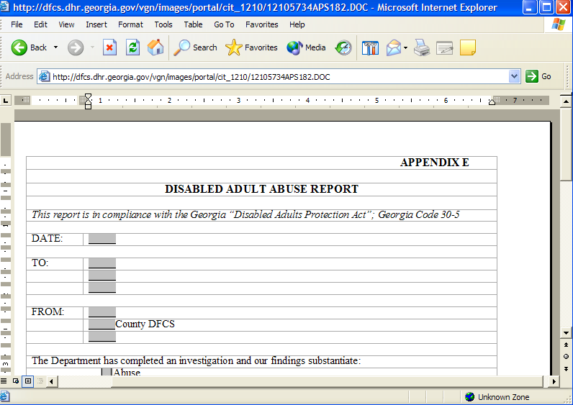
- The next step is to Save the Form.

Saving a Form

To save a form: (Please Note There Are Two Different Methods Illustrated Here)

Option 1

- Choose File > Save As… from the File menu to save the document on your hard drive. (Continue With #2 Below)
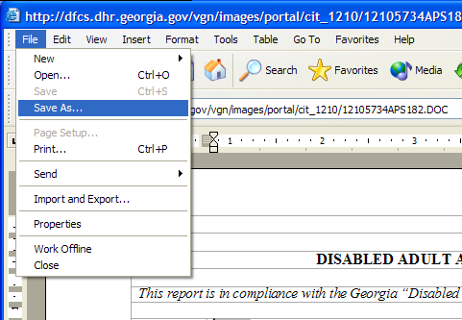

Option 2

1. Select your desired form and Right-Click the mouse. Select the Save Target As… option. The APS 182
form has been selected in the example below. (Continue With #2 Below)

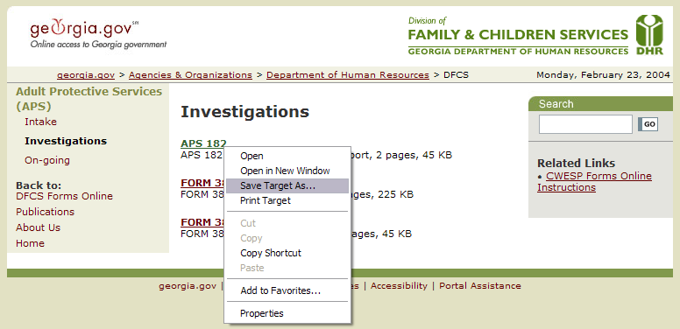

- Choose the appropriate directory to save the file in and provide a filename. In this example, the My Forms directory (i.e., C:\My Documents\My Forms) is chosen. DO NOT SAVE YET.
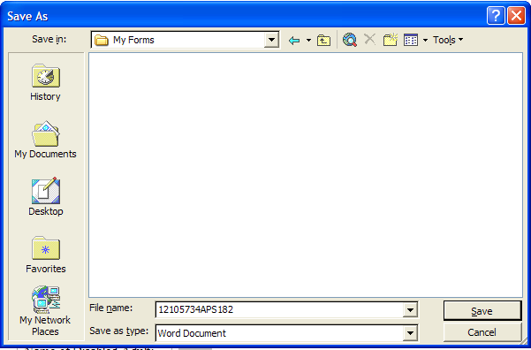
NOTE: The File name will need to be modified prior to saving the document to your local hard drive or Novell network drive.
- To modify the file name, place your cursor in the File name: field. In this example, the APS 182 Disabled Adult Abuse Report form was chosen. Modify the file name from 12105734APS 182 to APS 182.

- After renaming the file, left-click on Save to save the file to the location on your hard drive
Novell network drive that you previously specified.
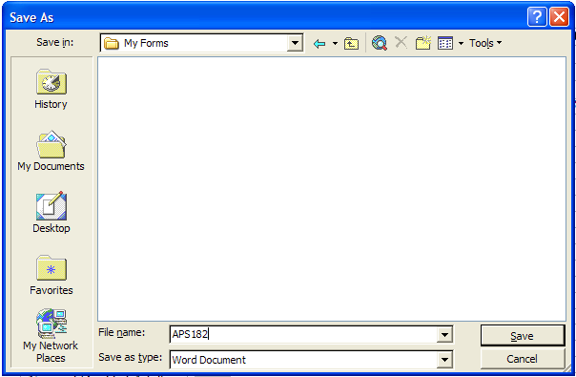

Open a Saved Form

To open a saved form:
- Start Microsoft Word by choosing Start > Programs > Microsoft Word or choose the Microsoft Word icon on the desktop, if available.
- Choose File > Open… from the menu bar.
- Browse to the desired directory. In the preceeding examples, the My Forms directory is the desired directory.
- Select the DFCS CWESP Form you wish to open and double-click on it to open the form.
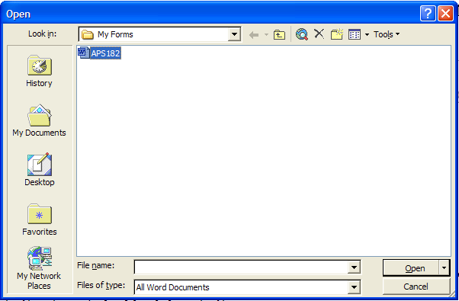

Working with Forms

You will now have a blank version of the form on your computer that can be used repeatedly. This version can be opened and modified by entering data into any of the editable fields indicated with gray highlighting as shown below.

After modifying the document with specific case information, you can save the modified version using the Save As… instructions described above. [For example: A blank APS 182 Disabled Adult Abuse Report form can be saved in your hard drive and re-saved multiple times by using different file names when populated.]
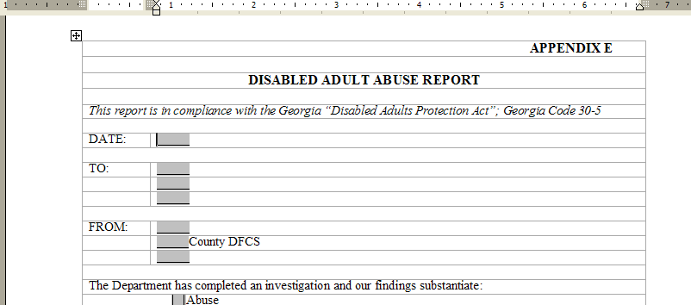

Frequently Asked Questions

- Who do I contact if I cannot access the forms at http://dfcs.dhr.georgia.gov/formsonline?
If the DFCS CWESP Forms Online web site is not responding, please report the outage to webmaster@dhr.ga.gov.

